**Overview**

ABC Supply is moving the systems that are currently integrated with their portal and intranet into Okta. Okta is software as a service that provides secure identity management and single sign-on. The current Owens Corning Customer Portal is using ABC Supply’s portal for authentication and will need to be updated to use Okta. In addition, Owens Corning is rolling out a new version of their customer portal. The plan is to setup Owens Corning’s new portal to utilize ABC’s Okta account. The diagram below outlines of the integration:

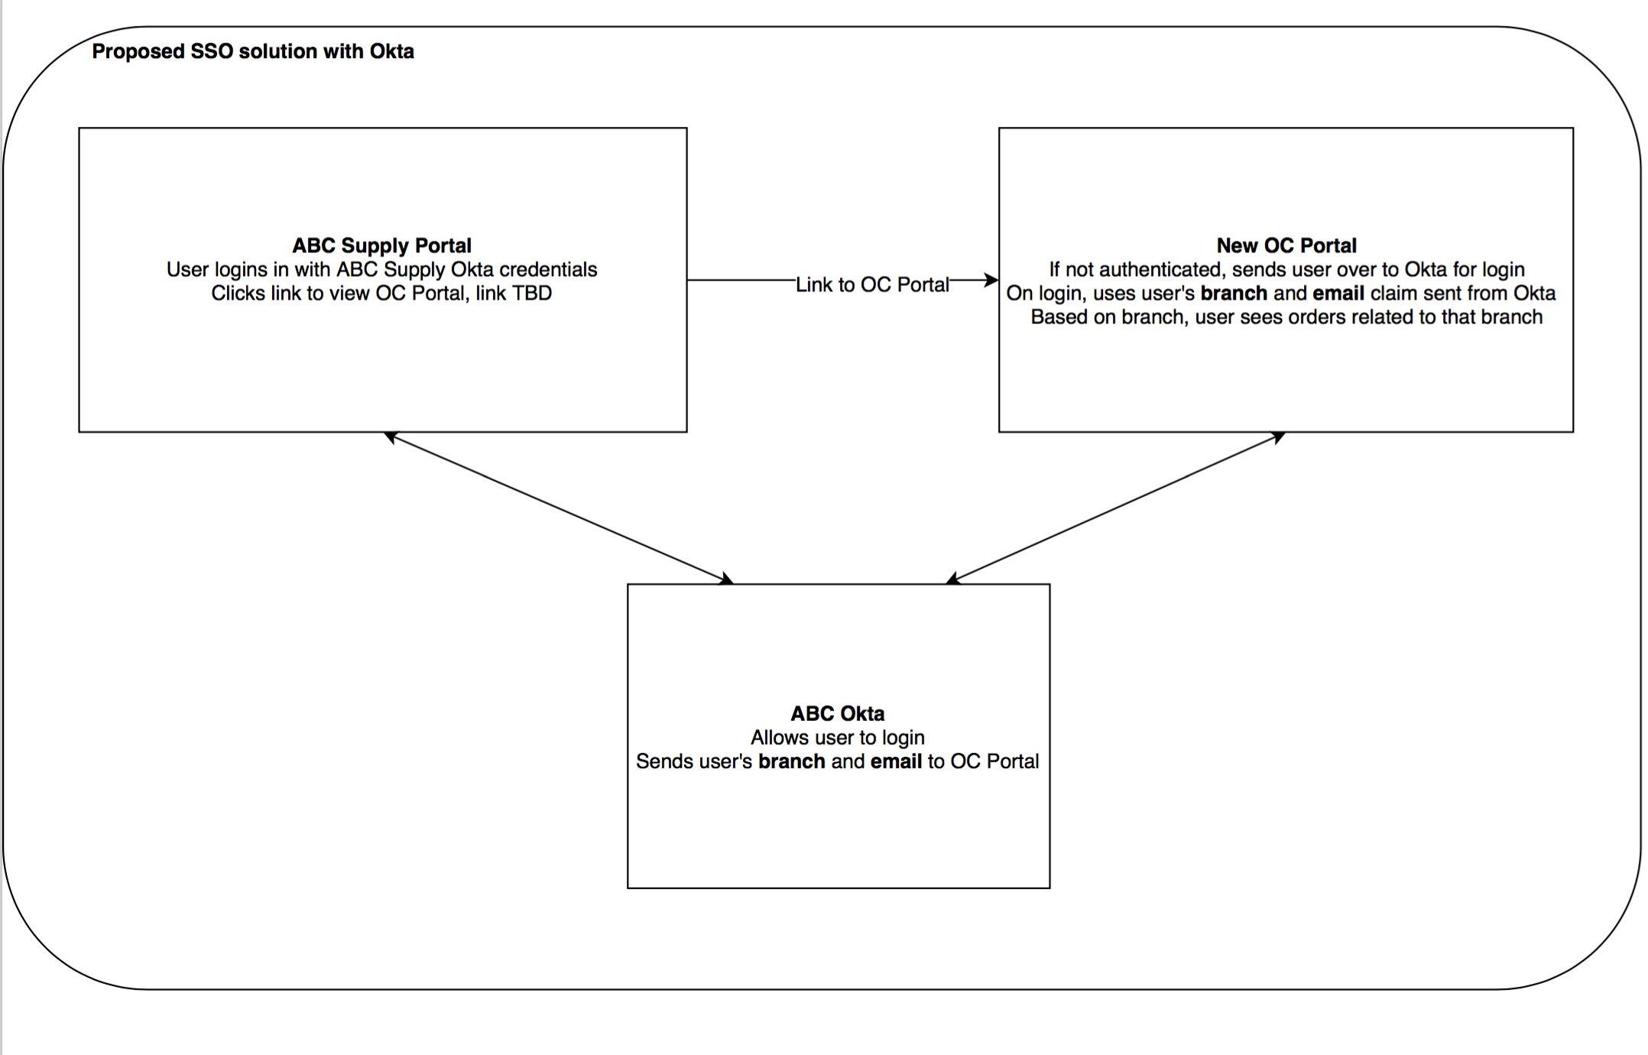

**Owens Corning Portal Required User Attributes**

Each user of the Owens Corning portal needs to be associated to an ABC supply branch.

The branch the user is associated with determines what orders the user will be able to see.

Additionally, the user’s email, first name and last name should be given.

It is expected these attributes be passed through the SSO process.

**Okta Application Setup**

In order to configure Owens Corning’s Portal to use ABC’s Okta, an Owens Corning SAML 2.0 application must be first setup in ABC’s Okta account. Details of how to setup an SAML 2.0 application in Okta can be found here:

<https://developer.okta.com/standards/SAML/setting_up_a_saml_application_in_okta>

In **Step 7** set the “Single sign on URL” and “Audience URI (SP Entity ID)” to:

<https://login.owenscorning.com/users/auth/okta-abc/callback> (TBD)

In **Step 8** – add the following attributes statements

**FirstName** – the first name of the user

**LastName –** the last name of the user

**Email –** the email of the user

**Branch –** the branch the user is associated with

**Step 10** contains the information to configure SAML in our application, please send that to us in a password protected zip.

**Questions/Assumptions (TBD)**

1. Will all ABC users have an abcsupply.com email address?